Energy Transformations
Activity: For each of the energy transfers fill in the spaces using the words in the box.
A clockwork car

movement stored stored

Energy .............. in my body energy.................. in the ..................energy of
wound-up spring the clockwork car

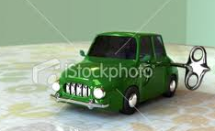
A battery and a lamp bulb
heat stored light electrical
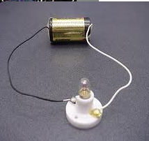
.............. energy of the bulb
Energy ............... in ........................energy
the battery .............. energy warming up
the bulb

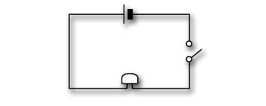A battery and a buzzer
sound stored energy electrical

................ ............... in the battery ........................energy ...................... energy
of the buzzer

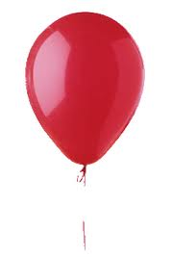A blown up balloon and then released.

stretched body movement stored

Energy stored in my ................ energy .............. in the .........................energy
............... balloon of the balloon

A Bunsen burner
light heat gas stored chemical

.............. energy lighting up the room
.................... energy ............... in the ............
.............. energy of the flame



